**TGE electron energy spectra: Comment on “Radar Diagnosis of the Thundercloud Electron Accelerator” by E. Williams et al. (2022)**

A. Chilingarian, G. Hovsepyan, D.Aslanyan, T. Karapetyan, B. Sargsyan, and M.Zazyan

*A. Alikhanyan National Lab (Yerevan Physics Institute), Yerevan 0036, Armenia*

**Abstract**

E. Williams et al. (2022, commented paper) questioned electron energy spectra derived from thunderstorm ground enhancements (TGEs) measured on Aragats; they conclude that “A more likely origin for any detected electrons at 3.2 km above sea level is Compton scattering and pair production activated by longer-range bremsstrahlung gamma rays, themselves produced by runaway electron encounters with nuclei in breakeven field at higher altitude “.

In this comment, we show that the selection criteria of “electron” TGEs unambiguously reject the assumption of the origination of TGE electrons measured on Aragats from the Compton and pair production processes. Thus, the strong accelerating electric field above the earth’s surface can be significantly lower (25-150 m) than derived in the commented paper 500 m altitude.

**Key points**

* The contribution of the Compton scattered and pair-production electrons to TGE flux are negligible and cannot “mimic” the TGE electron flux.
* The criteria used in the energy spectrum recovery from Aragats Solar Neutron Telescope (ASNT) reliably select “electron” TGE events and reject TGE events with small electron content.
* If the strong accelerating electric field is low above the earth’s surface (25-150 m) electrons from the large RREAs reach ASNT and their energy spectrum can be reliably recovered.

1. **Introduction**

In the commented paper, proceeding from thunderstorm ground enhancements (TGEs) observed on Mt Aragats (3.2 km above sea level), the altitude-resolved S-band radar observations of graupel are used to demonstrate distinct differences in storm structure relative to the near-surface electric field (NSEF) polarity. The authors conclude, that the altitude of downward electron acceleration and avalanching may be sufficiently distant (>500 m) from surface detector, and electrons observed by Aragats detectors, are not likely avalanche/runaway electrons. Instead, they are Compton-scattered and pair-produced electrons from bremsstrahlung gamma radiation emanating from the high-field avalanche region aloft.

We will demonstrate that simulations of the particle transport in the atmosphere and calculations of the spectrometer response function do not confirm this statement, and vice versa they demonstrate that both Compton scattering and pair production of the gamma ray “beam” does not produce enough energetic electrons to mimic the electron spectra, which measured on Aragats.

When gamma rays and electrons that multiplied in the relativistic runaway electron avalanche (RREA, Gurevich et al., 1992, Babich et al., 2001, Dwyer, 2003), exit the region of the strong electric field, electrons of MeV energies lose almost a fixed portion of energy crossing each meter of air (≈200 KeV at altitudes 3-4 km), whereas the gamma rays lose at each meter only a small percent of their intensity. Evermore, the abundant RREA electron flux going out of the strong electric field region, born additional bremsstrahlung gamma rays, therefore, the intensity of low and middle energy gamma rays, which reach the ground can increase, instead to be decreased.

In Fig. 1 we show the histograms of the energies of electrons and gamma rays reaching the earth’s surface after RREA exits the strong electric field. In the insets, we show the number of electrons (Ne) and gamma rays (Nγ) reaching the earth’s surface for different energy ranges. We used the CORSIKA code (Heck et al., 1998) version 7.7400, which takes into account the effect of the electric field on the transport of particles (Buitink et al., 2010). We examined the RREA process for various vertical profiles of the atmospheric electric field, and select plausible combinations of the field strength and extension, which support RREA emergence (Chilingarian et al., 2021a, Chilingarian et al., 2021b, and Chilingarian et al., 2021c). Using several particular electric field parameters (field strength Ez=2.0 kV/cm, field extension 2 km) we simulate the RREA propagation using seed electrons with fixed energy of E0=1 MeV. The height of the accelerating electric field termination was preset to 200 m (1a) and 25 m (1b). The gamma ray “beam” traveling in the air undergoes various well-known interactions with air atoms. The most important of them are the photoelectric effect, pair production, and Compton scattering (in a MeV region, Compton scattering is the dominant process). Almost all electrons coming from 200 m will lose their energy in interactions with air atoms, only electrons, which will be generated by gamma rays by pair production and Compton scattering in the vicinity of the earth, will reach the ground.

However, as we can see in the inset to Fig 1a the electron content of RREA reaching the ground is ≈1% or less relative to the gamma ray content for all electron energies of interest. Obviously, for such a small fraction, it is not possible to separate the electron flux from the predominant gamma ray flux by disentangling the energy release histograms, it can be done only if the electron to gamma ray ratio is approximately an order of magnitude larger. A detailed description of the Aragats solar neutron telescope (ASNT) and the method of energy spectra recovery can be found in (Chilingarian et al., 2022a) and in the next section, where we formulate the necessary condition for the revealing existence of TGE electrons.

If the accelerating electric field continued until 25 m above ground, the electron content is largely exciding the gamma ray content (see the inset to fig 2b). Thus, only if a strong accelerating electric field is well below 200 m RREA electrons can be registered by particle detectors, and their energy spectrum can be recovered.

In the second section, we will describe the ASNT spectrometer and explain the electron flux validating procedures. In the third section, we will present TGE events registered on Aragats in 2019-2021 and discuss their characteristics necessary for the electron spectrum recovery. In the fourth section, we will formulate the special criteria for the “electron TGEs” on the example of TGE registered on 27 June 2020.

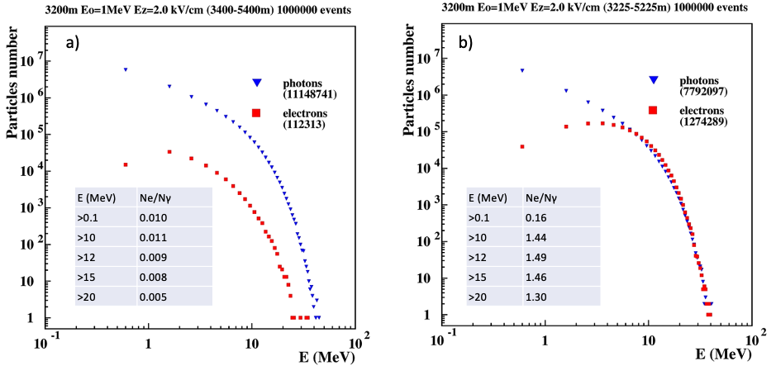

**Figure 1. The comparison of the energy spectra of the gamma rays (parent particles) and Compton scattered electrons. The accelerating electric field terminates at the height of 400 m above detectors.**

1. **Revealing TGE electrons by the Aragats Solar Neutron telescope (ASNT) measurements**

The electron energy spectra were recovered from energy release histograms measured by the ASNT spectrometer shown in Fig.2a. The name of the spectrometer is a historical one; the primary goal of its operation started 20 years ago was the registration of the direct neutrons originated in the violent solar flares. The spectrometer consists of 4 modules, each of 2 stacked scintillators of 5 cm (veto layer, scintillators 5-8) and 60 cm thickness (spectrometric layer, scintillators 1-4). The efficiency to register electrons in both layers is > 95%; to register gamma rays 5-6% for the thin scintillator, and 40-70% for the thick one. The count rates corresponding to all possible coincidences between 2 layers (within one microsecond) are separately counted and stored every minute (after 2012 – every 2 seconds). We store also time series of count rates corresponding to the “01” coincidence – if the signal is in the lower layer only (mostly gamma rays), and corresponding to “11” coincidence – signals in both layers of the spectrometer (mostly electrons). Additionally, the energy release histograms in both layers of the ASNT spectrometer, and energy releases corresponding to the “01” coincidence (with a veto on charged particles) are stored each minute.

In Fig. 2b we show the count rates of “11” coincidence. coming within the near-vertical direction in the cone of 0º - 22º (black curve) and within the zenith angle of 22º - 58º (colored curves). Only the vertical direction of the TGE particle arrival demonstrates 4 minute long large peak (≈14 standard deviations) because electrons are accelerated by a vertical intracloud electric field. Inclined trajectories do not observe any count rate enhancement. 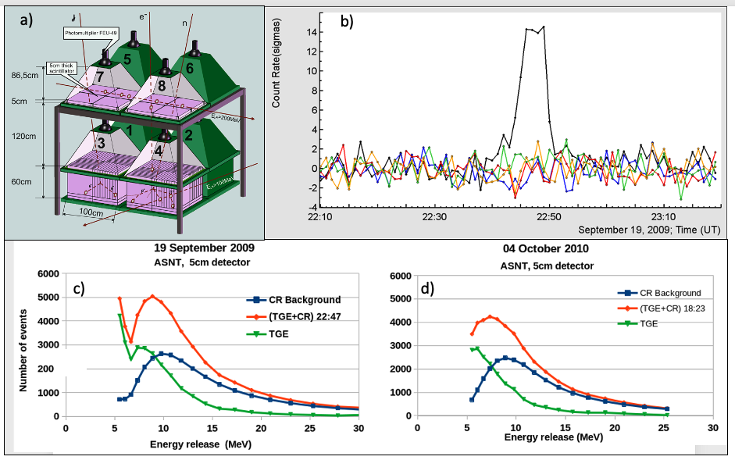

**Figure 2. a) the layout of the ASNT spectrometer; b) 1-minute count rate of ASNT “11” coincidence for 5 angles of incidence; c) the recovery of the energy release histogram in the upper 5 cm thick plastic scintillator (green) for the TGE observed in September 2009; d) the same for TGE observed in October 2010.**

In Fig. 2c we demonstrate the energy release histograms in the 5 cm thick scintillator at minute 2:49 - 22:50 on 19 September 2022. From the energy release histogram measured during TGE (red curve), we subtract the background histogram measured on fair weather before the TGE start (blue curve). The residual green curve represents the energy releases of the TGE gamma rays and electrons in a 5 cm thick scintillator. As we can see in Fig. 2c the energy releases during TGE peaked at 8-9 MeV, as electron losses in the scintillator are ≈ 1.8 MeV per centimeter. The green curve is smeared by energy releases of gamma rays occasionally giving energy release in the 5 cm thick scintillator (the efficiency to register gamma rays is 5-7%). However, the energy releases of gamma rays have an exponential shape and do not produce any peak in the histogram, as we can see in Fig. 2d (green curve), where we show another large TGE observed on 4 October 2010. This TGE does not contain electrons (the accelerating electric field stopped high above the earth’s surface and the electron flux attenuate before reaching the spectrometer) and we detect no peak in the TGE energy release histogram. Thus, if we have a large peak in the time series of “11” coincidence (Fig.2b) and a peak in the energy releases in the 5 cm thick scintillator (green curve in Fig. 2c), we can be sure that TGE contains sizeable electron share.

Experimentally, the electron energy spectrum was recovered from energy release histograms in the 60 cm thick scintillator, by subtracting the “01” histogram from the overall energy release histogram (without veto option). The gamma ray energy spectrum is obtained from the “01” energy release histogram. We solve the inverse problem of recovering energy spectra from energy release histograms using a detailed simulation of the detector response made with GEANT4 code (see details in Chilingarian et al., 2022).

In Fig.3 we show the energy release histograms registered by ASNT from the millions of gamma rays and electrons obtained from RREA simulations presented in Figs. 1a and 1b. Gamma rays and electrons were transported through the exact model of the ASNT detector implementing all experimental procedures. Finally, for the “survived” particles energy releases in the 60 cm thick scintillator were estimated. In Fig. 3a we show the energy releases distribution corresponding to the ”11” coincidence (red curve, electrons) and to the “01” coincidence (blue curve, gamma rays). The analogous distribution for simulated gamma rays is shown in Fig. 3b. The large depletion of the electron flux can be explained by the ionization losses of electrons in the upper 5 cm thick scintillator and in the metal of detector housings and roof of the building (≈15 MeV in total). Only 1.28 % of simulated electrons that reach 3200 m were registered by the ASNT lower scintillator if the electric field terminated 25 m above the spectrometer (blue curve of Fig.3a, 16,269 from 1,274,689). If the electric field terminates 200 m above the spectrometer and electrons are born in the air above the detector by the “gamma ray beam”, this ratio is much smaller, only 0.2% (red curve of Fig.3a, 249 from 112,313). The analogous numbers for the gamma ray flux are correspondingly 3.3% for the 25 m (blue curve in Fig. 3b, 257,237 from 7,792,097) and 4.3% for 200 m (red curve in Fig. 3b).

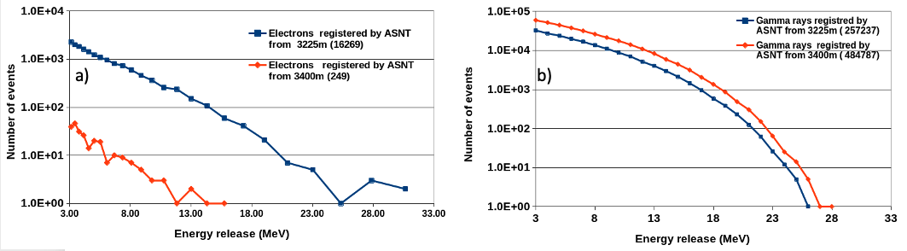

**Figure 3. a) energy release histogram of TGE electrons in lower thick scintillator of the ASNT spectrometer, red – electric field terminated 200 m above the detector, blue – 25 meter above detector; b) the same for gamma ray flux. Both fluxes were simulated by CORSIKA code with parameters described in Fig. 1.**

In the experiment, we haven’t pure gamma ray and electron fluxes as in simulation. Sure, the ASNT spectrometer cannot distinguish electron energy release from the gamma ray energy release. We can isolate electrons only statistically, subtracting the “pure gamma ray histogram” (coincidence “01”) from the total energy release histogram. Obviously, to recover electron energy spectra, we need a sizable portion of electrons in the joint energy release histogram registered by ASNT (Ne/Nγ to be well above the statistical fluctuations of the recovered gamma ray flux). In recovering procedure, we keep this ratio high enough to limit the maximum energy of the recovered spectrum. For the simulations (Fig 1), using the ASNT detector response function we estimate the Ne/Nγ ratio:

Ne/Nγ (25 m) = 16,269/257,237 ≈ 6.3%; Ne/Nγ (200 m) = 249/484,787 ≈ 0.05%.

Thus, the electron content is more than 100 times more for the RREAs developing in the electric field prolonging to 25 meters above the ground compared with RREAs going out of the electric field at a height of 200 m above the ground. Therefore, if the electric field terminates on 200 m above the ground, in the joint histogram of energy releases is expected only 249 electrons (0.05 relative to gamma rays), and the recovery of electron energy spectrum obviously could not be done. If the electric field is prolonged down to 25 m above the ground, using ≈16,000 electrons (6.3% relative to gamma rays) it will be possible to recover the electron energy spectrum. Consequently, Compton scattered and electrons from the pair production never can mimic TGE electrons as it is claimed in the commented paper.

1. **Characteristics of selected TGE events with large electron content**

In Table 1 we show several parameters of TGEs, that occurred during the 3 last years (2019-2021), for which we recover the electron energy spectrum. A full set of TGE parameters is available from the Mendeley data set (Chilingarian et al., 2021d). In the first column, we put the date of the TGE. In the second column, we post the TGE significance - we show the significance of the TGE by the percent of the enhancement above the mean value measured on fair weather and by the number of standard deviations from the mean value (the time series of the count rate of SEVAN detector upper scintillator was used. In the third column, we post the TGE duration; in the fourth column, we show the share of electron flux relative to gamma ray flux (see details of spectra recovery method in Chilingarian et al., 2022a). In the last column of Table, we show the significance of the “electron” peak (the “11” coincidence) similarly to the peak measured by SEVAN detector.

**Table 1. Parameters of electron and gamma ray energy spectra recovered from TGEs with sizable electron content in the energy release histograms corresponding to “11” coincidence, and estimates of the electric field height**

|  |  |  |  |  |
| --- | --- | --- | --- | --- |
| Date | SEVAN  significance (%/σ) | TGE duration (min) | Ne/ N𝛾 | ASNT “11” significance  (%/σ) |
| 06.18.19 | 13/16 | 6 | 0.18 | 4.6/6.1 |
| 06.14.20 | 20/24 | 4 | 0.15 | 5/7.8 |
| 06.27.20 | 9/17 | 19 | 0.26 | 6/7.6 |
| 09.25.20 | 26/32 | 5 | 0.19 | 3.8/4 |
| 05.24.21 | 9/11 | 13 | 0.11 | 5.1/5.5 |
| 10.06.21 | 46/55 | 3 | 0.11 | 10./11. |
| Mean | 20.5/26 | 8.33 | 0.17 | 5.8/7 |

The crucial condition of the significant peak corresponding to the “11” coincidence is fulfilled for all 6 selected TGEs, see the last column of Table 2. The mean enhancement above the fair-weather value is 5.8%, corresponding to 7σ significance. The significances of TGE events by the SEVAN detector are much larger due to the lower energy threshold of the detector. Averaged over 6 TGEs, the number of electrons at the minute of the maximal flux is 2107, and the number of gamma rays is 14,167. The fraction of electrons relative to gamma rays is 0.17 much larger than 0.03 assumed by Williams et al. on pages 27 and 28 of the commented paper.

1. **“Electron” TGE selection criteria**

For selecting TGE candidates, we apply to observed enhancement in the count rate standard requirements: peak significance should be above 3σ for at least 3 independent particle detectors and the absolute value of the near-surface electric field (NSEF) should be at least 5 kV/m. In Fig.4 we show the TGE occurred on 27 June 2020 (the third row in Table 1). TGE occurred at negative NSEF exceeding -20 kV/m, and the count rates of 3 plastic scintillators with the same area of 1 m2 and thicknesses 1, 3, and 5 cm peaked with significances of ≈17, 16, and 11σ. Lightning flashes at distances of 10 km and more do not terminate TGE.

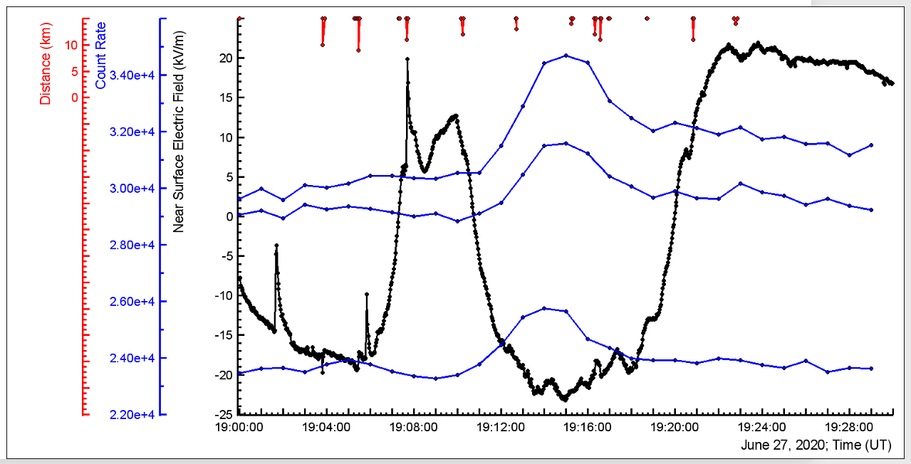

**Figure 4. TGE occurred on 27 June 2020. Black – disturbances of the NSEF, blue – count rates of 3 independent operating particle detectors, red – distances to lightning flashes.**

The next step in selecting “electron” TGE is to check peak significances in the ASNT spectrometer. In Fig. 5a we demonstrate peaks of TGE electrons (“11” coincidence, peak significance 7.6σ), and TGE gamma rays (“01” coincidence”, peak significance 40σ).

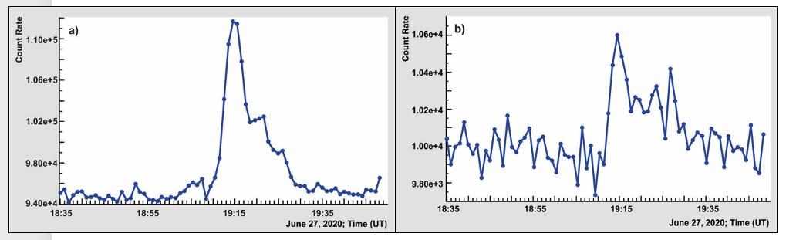

**Figure 5. 1-minute time series of count rates corresponding to the “01” coincidence (a) and (“11”) coincidence (b).**

The significant peak in the “11” coincidence is the necessary condition for starting electron energy spectra recovery. However, to the “11” peak significance condition we plan to add an additional criterium suggested by the anonymous referee: the presence of a peak in the energy release distribution of the upper, 5 cm thick scintillator of the ASNT spectrometer, see green curves in Figs.2c and 2d.

1. **Conclusions**

If the accelerating electric field is terminated high above the ground (>200 m) TGE electrons are attenuated, and recovery of electron energy spectra is not feasible. The contribution of the Compton scattered and pair production electrons are negligible and such TGEs never will pass the selection criteria for the “electron TGE” candidates. The electron energy spectrum recovered only for TGEs with large significances, according to SEVAN detector measurements and, which passed the special criteria for “electron” TGEs

The ultimate selection criteria for the “electron” TGEs are the presence of a sizable peak in the time series of count rate of the “11” coincidence (signals both in the upper 5 cm thick, and in the lower, 60 cm thick ASNT scintillators) and the peak in the region 8-9 MeV in the distribution of energy releases in the upper ASNT scintillator.

**Data availability statement**: The data that support the findings of this study are openly available at the following URL: http://adei.crd.yerphi.am/ and http://37.26.168.91/TGEsimul/

**References**

L.P. Babich, I.M. Kutsyk, E.N. Donskoy, et al., Comparison of relativistic runaway electron avalanche rates obtained from Monte Carlo simulations and kinetic equation solution, IEEE Trans. Plasma Sci. 29 (3) (2001) 430–438. https://doi.org/ 10.1109/27.928940.

S.Buitink,H.Falcke,etal.,MonteCarlosimulationsofairshowersinatmospheric electric fields, Astropart. Phys. 33 (2010) 1.

A.Chilingarian, T.Karapetyan, H.Hovsepyan, et. al. (2021a). Maximum strength of the atmospheric electric field, PRD, 2021, 103, 043021.

A.Chilingarian, G. Hovsepyan, and M. Zazyan (2021b). Measurement of TGE particle energy spectra: An insight in the cloud charge structure, Europhysics letters, 134 6901, https://doi.org/10.1209/0295- 5075/ac0dfa

A. Chilingarian, G. Hovsepyan, E. Svechnikova, and M. Zazyan, (2021c). Electrical structure of the thundercloud and operation of the electron accelerator inside it, Astroparticle Physics 132 102615 <https://doi.org/10.1016/j.astropartphys.2021.102615>.

Chilingarian, Ashot; Hovsepyan, Gagik (2021d). “Dataset for 16 parameters of ten thunderstorm ground enhancements (TGEs) allowing recovery of electron energy spectra and estimation the structure of the electric field above earth’s surface”, Mendeley Data, V3, doi: 10.17632/tvbn6wdf85.3  
https://data.mendeley.com/datasets/tvbn6wdf85/3

A.Chilingarian, G. Hovsepyan, T.Karapetyan, et al. (2022a). Measurements of energy spectra of relativistic electrons and gamma-rays avalanches developed in the thunderous atmosphere with Aragats Solar Neutron Telescope, Journal of Instrumentation,17 P03002.

A.Chilingarian, G.Hovsepyan, T.Karapetyan, B.Sargsyan, and M.Zazyan (2022b) Development of the relativistic runaway avalanches in the lower atmosphere above mountain altitudes, EPL, DOI: https://doi.org/10.1209/0295-5075/ac8763

J.R. Dwyer, A fundamental limit on electric fields in air, Geophys. Res. Lett. 30 (20) (2003) 2055. https://doi.org/10.1029/2003GL017781.

A.V. Gurevich, G. Milikh, R. Roussel-Dupre, Runaway electron mechanism of air breakdown and preconditioning during a thunderstorm, Phys. Lett. A 165 (1992) 463.

D. Heck, J. Knapp, J.N. Capdevielle, G. Schatz, and T. Thouw, Report No. FZKA 6019, 1998, Forschungszentrum, Karlsruhe, https://www.ikp.kit.edu/corsika/70. php.

Williams, E., Mkrtchyan, H., Mailyan, B., Karapetyan, G., & Hovakimyan, S. (2022). Radar diagnosis of the thundercloud electron accelerator. Journal of Geophysical Research: Atmospheres, 127, e2021JD035957. https://doi. org/10.1029/2021JD035957