**My comments (in blue) to the “Comparison of light spots”**

* In the first raw I post the 3 camera shots, in the middle 2 camera, in the bottom – 1 camera, located 85 m apart and 1.8 m higher.
* There is well correlation in time of tens of seconds between 1 and 2 cameras, we cannot expect also spatial correlation because of difference in the fields of view of remote cameras.

I am strongly convinced that the spatial correlation is a necessary condition to state that different cameras had detected the same sky object. Only time correlation is not enough, it simply reflects the fact that the favorable conditions for the occurrence of the glows in the field of view of different cameras are satisfied at this time. And it is not surprising that for a given moment, when the near-surface electric filed is high enough, the corona discharge may or may not occur at the domes of different cameras where the local field strengths may differ.

As far as remember, the fields of view at least for two cameras Cam 1 and Cam 2 are nearly the same ( please compare attentively the right and left panels in the picture below which have you sent me on 13-June-2021 ). The fields of view are not identical, but they coincide quite well.

* The third camera well correlated both in time and spot position with other 2 only at 01:55, it didn’t operate properly at ~~10:45-47~~, 01:45-47 when was most intense flaring.

I cannot see any distinct pair of images from different cameras with same spot position and configuration. On the other hand, there are multiple examples when the images of different cameras with the same timestamp are quite different, and in particular, when the spots are detected only with one camera, whereas the image from other camera with the same timestamp is quite empty. The examples can be found in my file “October 3, 2021 glow.pptx” sent on Oct 3.

The substantial differences between the corresponding images cannot in any way be attributed to slightly different (non-identical) fields of view.

I consider these substantial differences observed in more than 10 pairs of images as a strong experimental evidence against the interpretation of the light spots as hypothetical sky objects.

* The hypothesis of RREA origin of the light spots can be rejected due to very long duration of flaring (10-15 seconds), the duration of electron avalanches is expected not more than microsecond. Maybe many avalanches can be produced in the same local areas ?
* I suspect also that corona discharges can be stable for tens of seconds and in 30 years nobody on Aragats detects any lights around metallic masts.

I agree that corona discharges can be stable for several seconds or tens of seconds.

Five images in slide 2 of the file “October 3, 2021 glow.pptx” which are almost unchanged during 5 seconds can serve as an example of such behavior of corona discharge.

Concerning the visual observation of optical emission from corona discharge,

I can remind and repeat here once again my old arguments (June 2020) :

Я предполагаю, что искрит непосредственно на корпус  камеры, и чаще - на ее края.

Заметь, что довольно часто изображения видны на краю поля зрения. Это не такое сильное свечение для глаза, чтобы персонал мог заметить. Не забывай,  что  азот  флуоресцирует в области 337-427 нм,а человеческий глаз не видит  ниже 430 нм ( в темноте чуть лучше, ниже 400 нм). То есть в лучшем случае, незначительно перекрываются хвосты распределений: длинноволновый край свечения и коротковолновая граница чувствительности глаза. Но если коронный разряд  искрит прямо на камеру, она это хорошо видит. Она чувствительна в области 300–700 нм.

* The only plausible hypothesis is intracloud lightning flaring, I many times saw it in the same place for many seconds.

I don’t know what is the “intracloud lightning flaring”, but I cannot agree with the statement that light spots are sky objects. By now, we have no single distinct experimental evidence for that.

* However, we need to reconstruct 3 dimensional patter of the light spots!

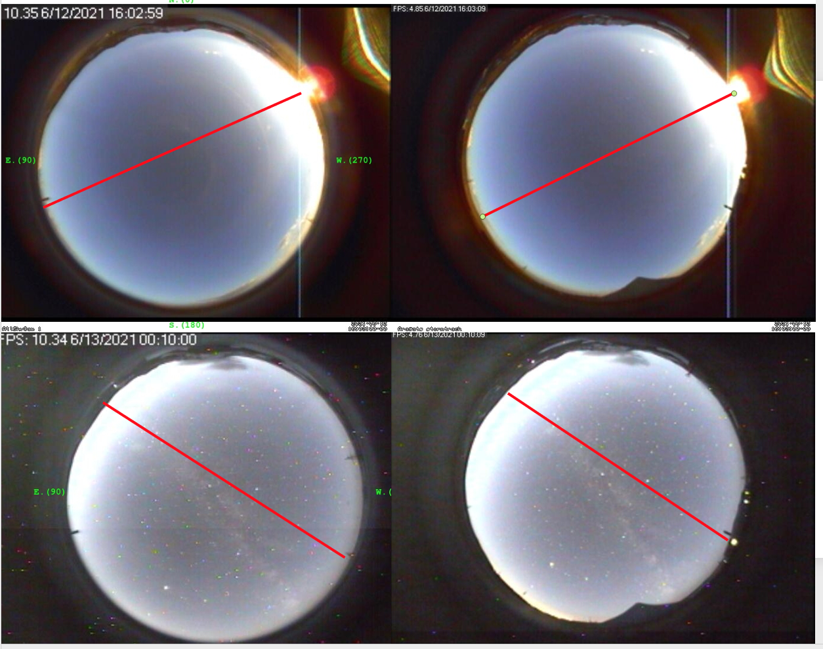

My conclusion.

So far, we have no experimental evidence that the light spots come from the sky.

According to the available experimental data, the most probable origin of

light spots is the optical emission from the corona discharge at the camera dome.