**Pulse positions for Cube 3 and Cube 6 detectors.**

**Updated on November 1, 2021**

Positions of pulses in filtered signals (amplitude threshold 48 mV) of two detectors Cube 3 and Cube 6 found within the record length of 200 ms and divided into bins of given width (from 10 ms to 10 µs ) and the coincidences of non-empty bins for two signals are counted as a function of bin width. This analysis is performed for the signals of two detectors recorded at the maximum of the TGE, and for ten randomly chosen records in fair weather. Coincidences of non-empty bins and Poisson probabilities calculated with average values of *λ* for 10 fair-weather records are summarized in Table 1. Fractions of coincidences of non-empty bins at the maximum of the TGE and in fair weather are illustrated in Fig.2. The curves show the ratios of coincidences to the number of bins during TGE ( k/ N ) and in fair weather (***λ/N*** ).

**Table 1 . Coincidences of pulses positions on the time axis of Cube 3 and Cube 6 detectors**

**at the maximum of TGE and in fair weather for different bin widths.**

|  |  |  |  |  |  |  |
| --- | --- | --- | --- | --- | --- | --- |
| 1 | 2 | 3 | 4 | 6 | 5 | 7 |
| **Bin width,** | **Number of bins**  **N** | **Number of coincidences**  **at the max. of TGE**  ***k*** | **Fraction of coincidences at the max. of TGE**  **k/N, %** | **Number of coincidences in**  **fair weather**  ***λ*** | **Fraction of coincidences in fair weather**  ***λ/N,* %** | **Poisson probability $p\left(k\right)=\frac{λ^{k}}{k!}e^{-λ}$**  **, %** |
| **20 ms** | **10** | **10** | **100** | **9.9** | **99** | **12.5** |
| **10 ms** | **20** | **20** | **100** | **17.2** | **86** | **7.2** |
| **8 ms** | **25** | **24** | **96** | **18.5** | **74** | **3.9** |
| **5 ms** | **40** | **33** | **82,5** | **20.3** | **51** | **0.25** |
| **4 ms** | **50** | **38** | **76** | **20.2** | **40** | **0.13** |
| **2.5 ms** | **80** | **37** | **46.25** | **17.9** | **22.4** | **0.003** |
| **1 ms** | **200** | **34** | **17** | **10.9** | **5.5** | **1.2 ⋅10-6** |
| **500 µs** | **400** | **20** | **5** | **5.7** | **1.4** | **1.8 ⋅10-4** |
| **250 µs** | **800** | **12** | **1,5** | **4.3** | **0.5** | **0.11** |
| **100 µs** | **2000** | **7** | **0,35** | **3.2** | **0.2** | **2.8** |
| **50 µs** | **4000** | **4** | **0,1** | **2.8** | **0.05** | **15.6** |
| **25 µs** | **8000** | **2** | **0,025** | **2.6** | **0.04** | **25** |
| **10 µs** | **20 000** | **2** | **0,01** | **2** | **0.01** | **27** |

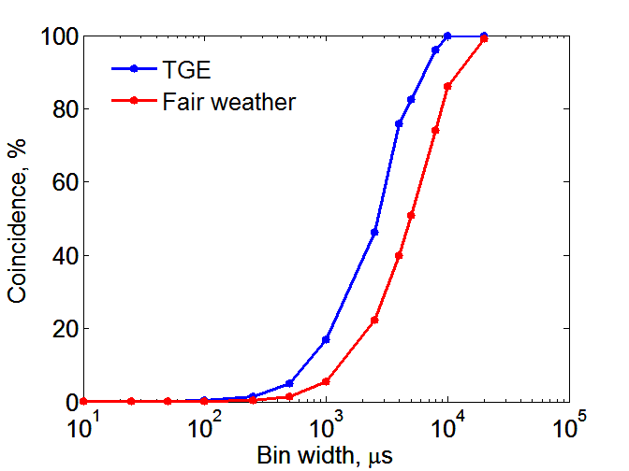

**Fig.1 . Coincidences of non-empty bins for signals of two detectors Cube 3 and Cube 6 at the**

**maximum of TGE (k/N, blue) and in fair weather (*λ/N*** **red) as a function of bin width.**

**Appendix A. Average values of expected coincidences (*λ )* for 10 fair-weather records**

**Table A2. Number of coincidences of non empty bins in two signals from 10 records in fair weather.**

|  |  |  |  |  |  |  |  |  |  |  |  |  |  |
| --- | --- | --- | --- | --- | --- | --- | --- | --- | --- | --- | --- | --- | --- |
| 1 | 2 | 3 | 4 | 5 | 6 | 7 | 8 | 9 | 10 | 11 | 12 | 13 | 14 |
| **Bin width** | **Number of bins** | ***λ1*** | ***λ2*** | ***λ3*** | ***λ4*** | ***λ5*** | ***λ6*** | ***λ7*** | ***λ8*** | ***λ9*** | ***λ10*** | ***λmean*** | **Fraction of coincidences of**  **non-empty bins %** |
| 20 ms | 10 | 10 | 10 | 10 | 10 | 10 | 10 | 10 | 9 | 10 | 10 | 9.9 | 99 |
| 10 ms | 20 | 17 | 17 | 15 | 17 | 17 | 19 | 17 | 16 | 18 | 19 | 17.2 | 86 |
| 8 ms | 25 | 19 | 19 | 17 | 18 | 19 | 19 | 15 | 18 | 20 | 21 | 18.5 | 74 |
| 5 ms | 40 | 22 | 18 | 22 | 20 | 23 | 18 | 14 | 19 | 21 | 26 | 20.3 | 51 |
| 4 ms | 50 | 21 | 19 | 24 | 21 | 22 | 15 | 17 | 21 | 19 | 23 | 20.2 | 40 |
| 2.5 ms | 80 | 16 | 15 | 23 | 18 | 18 | 14 | 11 | 19 | 21 | 24 | 17.9 | 22.4 |
| 1 ms | 200 | 9 | 10 | 15 | 12 | 8 | 12 | 6 | 15 | 9 | 13 | 10.9 | 5.5 |
| 500 µs | 400 | 4 | 4 | 6 | 7 | 5 | 5 | 3 | 7 | 6 | 10 | 5.7 | 1.4 |
| 250 µs | 800 | 4 | 4 | 7 | 4 | 2 | 4 | 3 | 6 | 3 | 6 | 4.3 | 0.5 |
| 100 µs | 2000 | 2 | 3 | 3 | 4 | 3 | 3 | 3 | 4 | 2 | 5 | 3.2 | 0.2 |
| 50 µs | 4000 | 2 | 2 | 4 | 3 | 3 | 2 | 3 | 2 | 2 | 5 | 2.8 | 0.05 |
| 25 µs | 8000 | 3 | 2 | 3 | 3 | 2 | 2 | 3 | 3 | 2 | 3 | 2.6 | 0.04 |
| 10 µs | 20 000 | 2 | 2 | 2 | 2 | 2 | 2 | 2 | 2 | 2 | 2 | 2 | 0.01 |