**TGE of October 6, 2021. Analysis of oscilloscope records in Matlab.**

The maximum of particle flux of the TGE that occurred on October 6, 2021 was observed at 2:03:04 UT (Fig. 1).

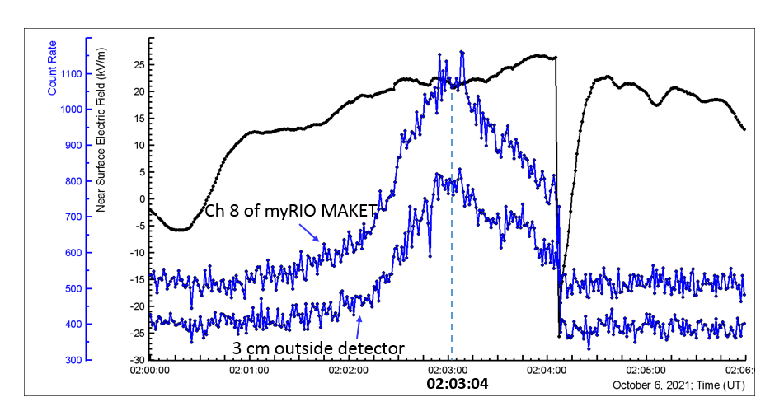

**Fig.1. Electric field (black) and count rates (blue) of two scintillation detectors. Red circle indicates the region where two oscilloscope traces selected for analysis were recorded.**

During the TGE, the signals from four scintillation detectors, one in MAKET and three in SKL experimental halls were recorded by oscilloscopes which were triggered via my RIO boards controlled by scintillation detectors as described in Table 1.

**Table 1. Oscilloscopes used for recording the signals of four scintillation detectors.**

|  |  |  |
| --- | --- | --- |
| Location | MAKET (N3)  2-Channel Picoscope 5244B | SKL2 (N4)  4-Channel Picoscope 6402D |
| Sampling frequency | 250 MS/s | 156.25 MS/s |
| Sampling interval | 4 ns | 6.4 ns |
| Amplitude range | Ch A ± 5 V  Ch B ± 1 V | Ch A, B, C ± 2 V  Ch D ± 20 V |
| Record length | 200 ms  time before and after trigger: -100, 100 ms | 200 ms  time before and after trigger: -100, 100 ms |
| Input signals | Ch A – Neutron Monitor N2  Ch B – Stand1, 3 cm scintillator | Ch A – CUBE 2  Ch B CUBE 3  Ch C - CUBE 6  Ch D – trigger pulse from myRIO |
| Trigger source | Detector used for triggering:  1 m2 STAND1 MAKET upper coupled to myRIO Ch 8 in MAKET  Threshold: 600 counts/ s | Detector used for triggering:  CUBE 6 coupled to myRIO Ch 8  in SKL2 (former DUVIK)  Threshold: 400 counts/s |
| Trigger mode | External | Ch D |
| Trigger threshold  (Picoscope settings) | 2V | 1.5 V |

Two selected oscilloscope records of detectors’ signals at the maximum of the TGE are analyzed below:

1) signal of 3 cm outside detector in MAKET recorded at 2:03:04 UT (Picoscope N3) and

2) signals of Cube 6 detector in SKL recorded at 2:03:09 UT (Picoscope N4).

Background records of these detectors are also analyzed. For each record, detector signal, distribution of positions of pulses on the time axis, and amplitude distribution of pulses are presented.

Two different thresholds for removal of pulses with small amplitude are used for each of the records.

The records of Cube 2 and Cube 3 detectors are also analyzed, the results are similar to those for Cube 6, and are not documented here . They are briefly presented in Table 3 at the end of the document.

1. **Picoscope N3 in MAKET, signal of 3 cm outside detector.**

Record length 200 ms, sample interval 4 ns. Amplitude measurement range ±1 V,

amplitude resolution 8 mV.

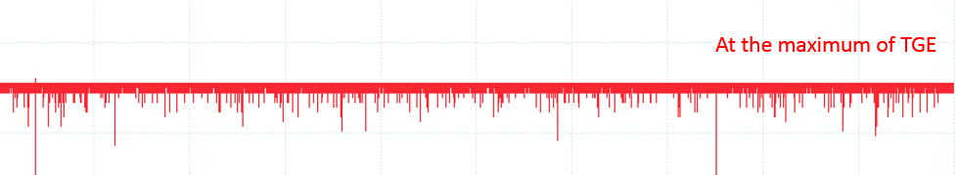

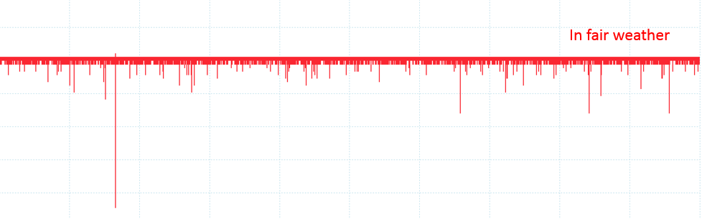

**Fig. 2. Oscilloscope records of the signal of 3 cm scintillation detector at the maximum of TGE, (October 6, 2021, 02:03:04 UT), and in fair weather (October 6, 2021, 20:59:18). Number of pulses recorded during TGE is larger than in fair weather.**

In data processing, filtering by amplitude is applied: pulses with amplitudes below given threshold (32 mV or 24 mV) are removed.

**1a) Threshold 32 mV**

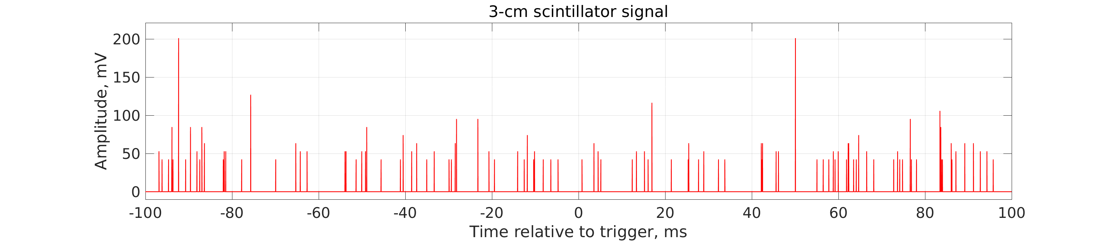

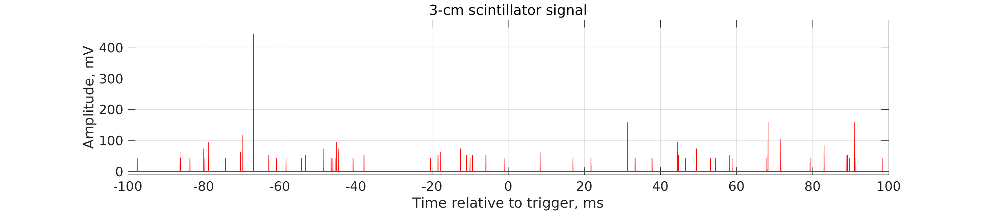

**Fig.3 Inverted signal of 3 cm outside detector . Upper panel: at the maximum of TGE , at 2:03:04UT October 6, 2021, number of peaks is 109. Lower panel: background at fair weather at 20:59:18 UT October 6, 2021, number of peaks is 63.**

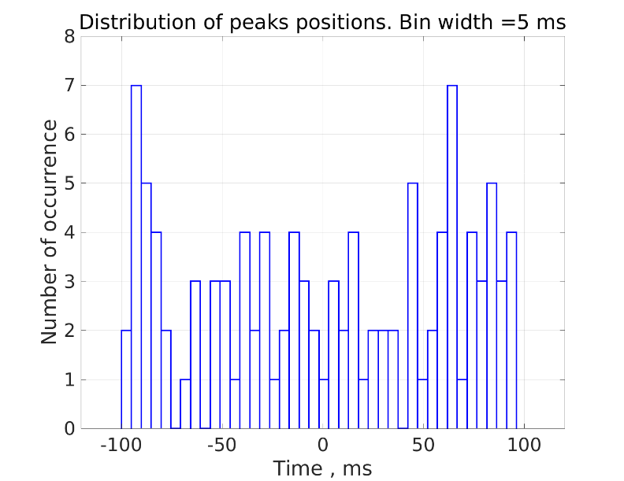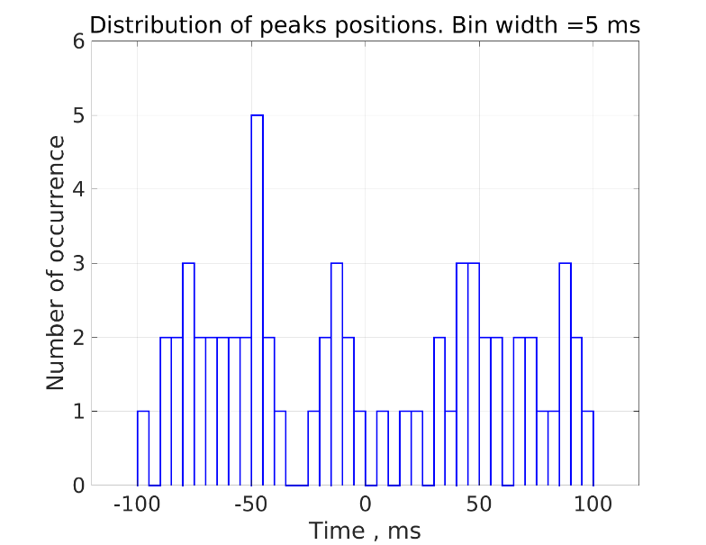

**Fig.4. Distribution of peaks’ positions. Left: at the maximum of TGE , at 2:03:04UT October 6, 2021, right: background at fair weather at 20:59:18 UT October 6, 2021**

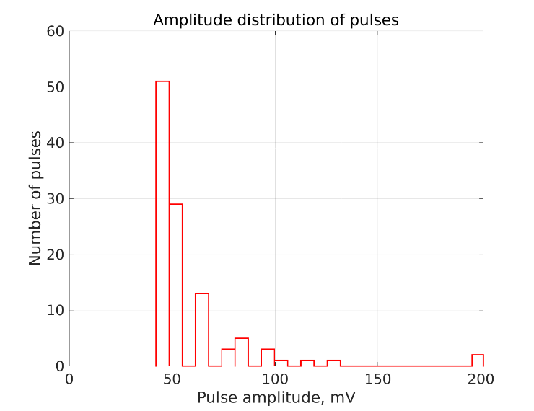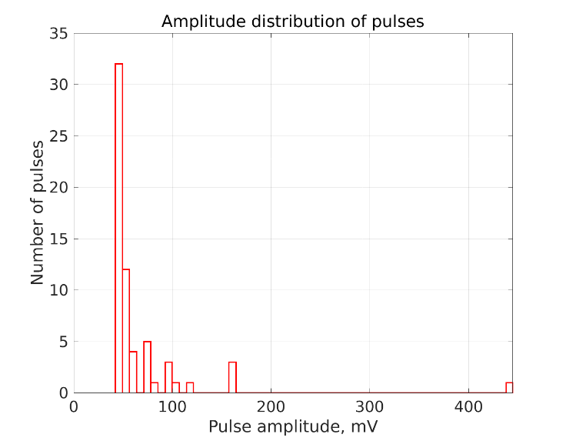

**Fig.5. Distribution of pulse amplitudes. Bin width 8 mV. Left: at the maximum of TGE, at 2:03:04UT October 6, 2021, right: background at fair weather at 20:59:18 UT October 6, 2021.**

**1b) Threshold 24 mV**

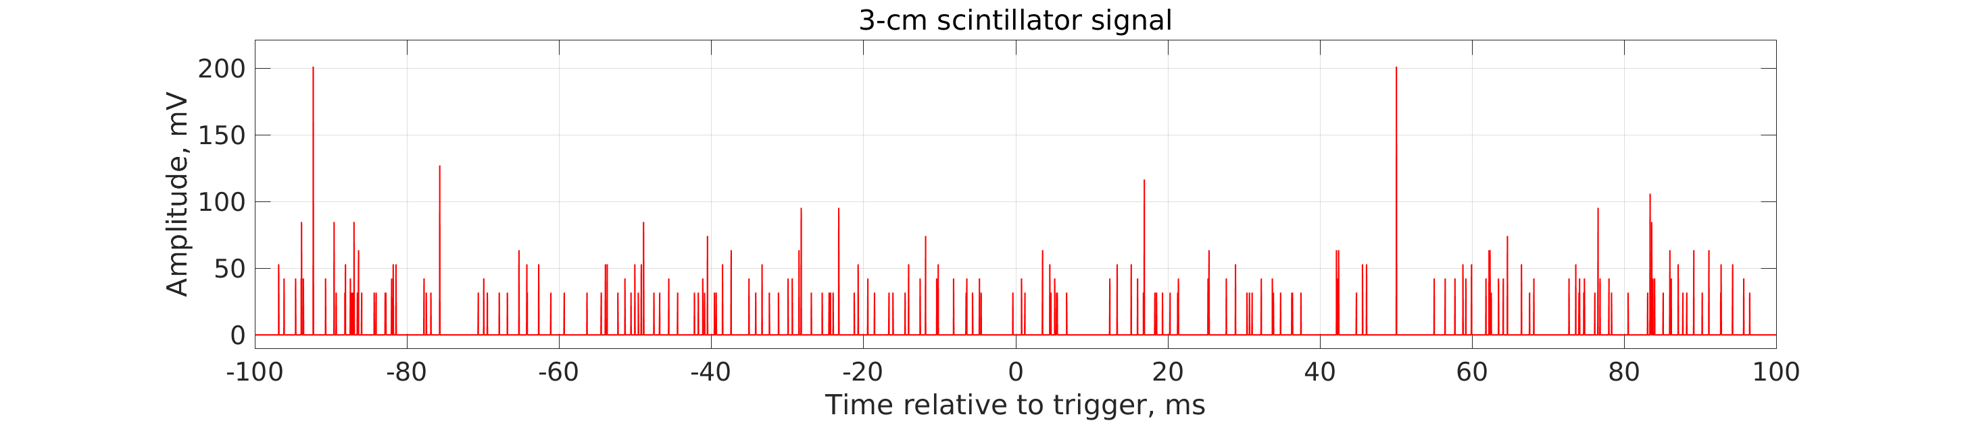

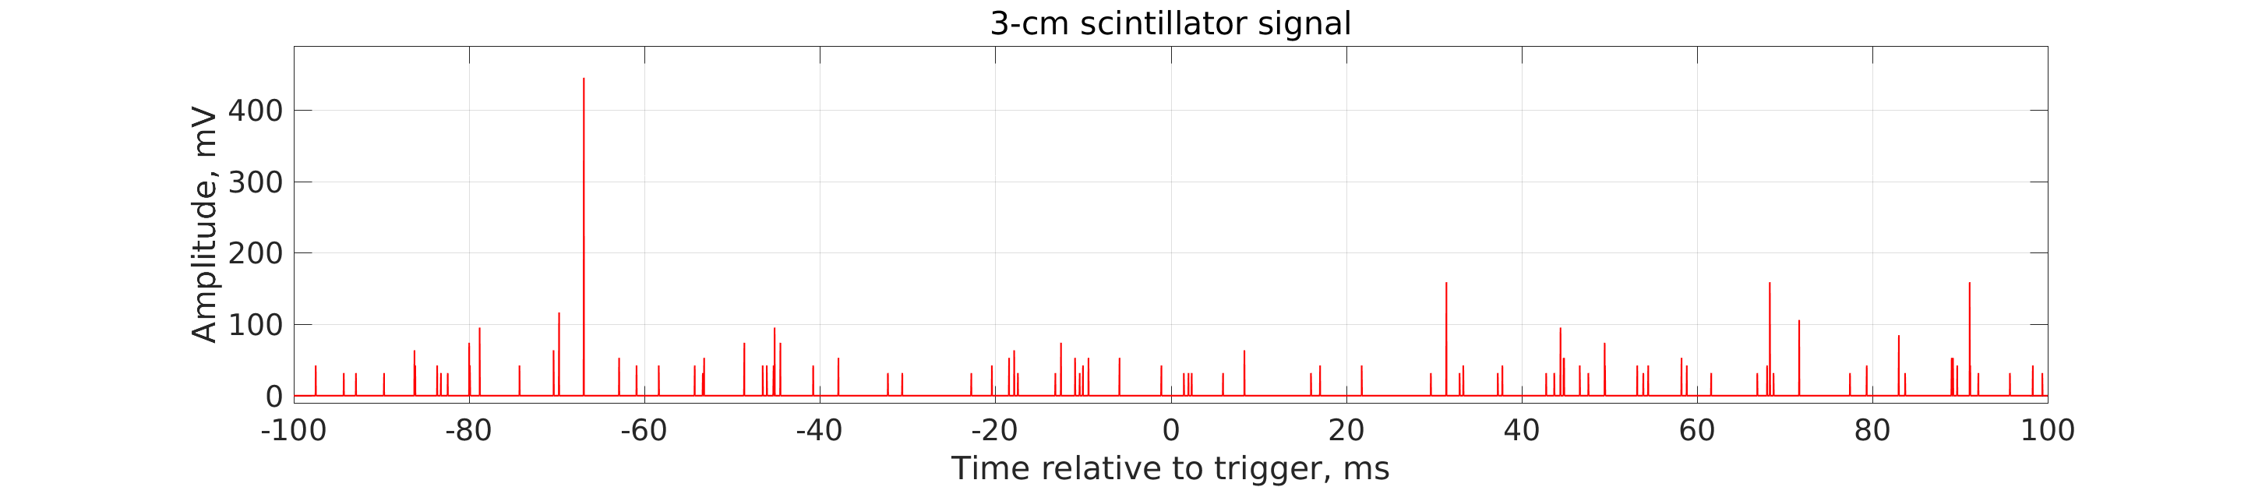

**Fig.6 Inverted signal of 3 cm outside detector. Upper panel: at the maximum of TGE , at 2:03:04UT October 6, 2021, number of peaks is 199. Lower panel: background at fair weather at 20:59:18 UT October 6, 2021, Number of peaks is 98.**

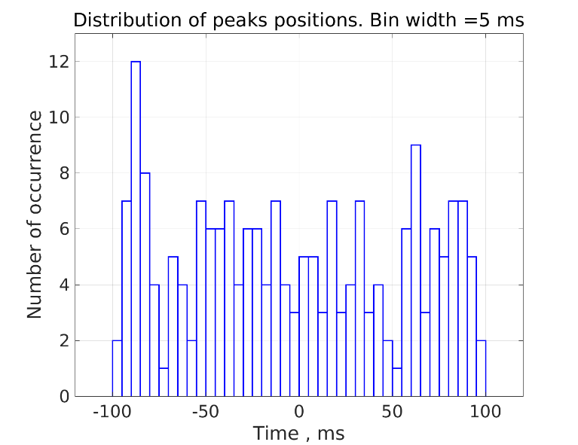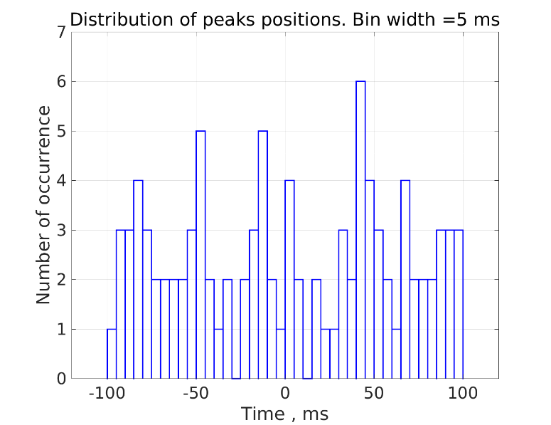

**Fig.7. Distribution of peaks’ positions. Bin width 5 ms. Left: at the maximum of TGE , at 2:03:04UT October 6, 2021, right: background at fair weather at 20:59:18 UT October 6, 2021.**

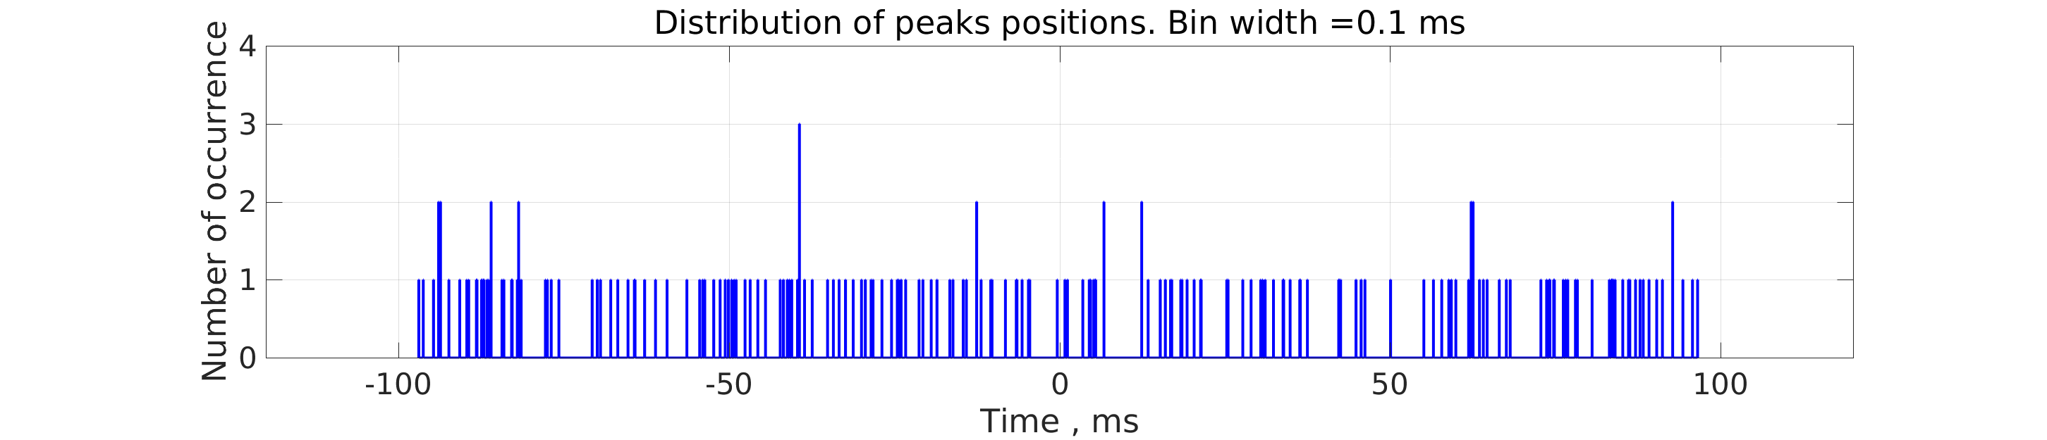

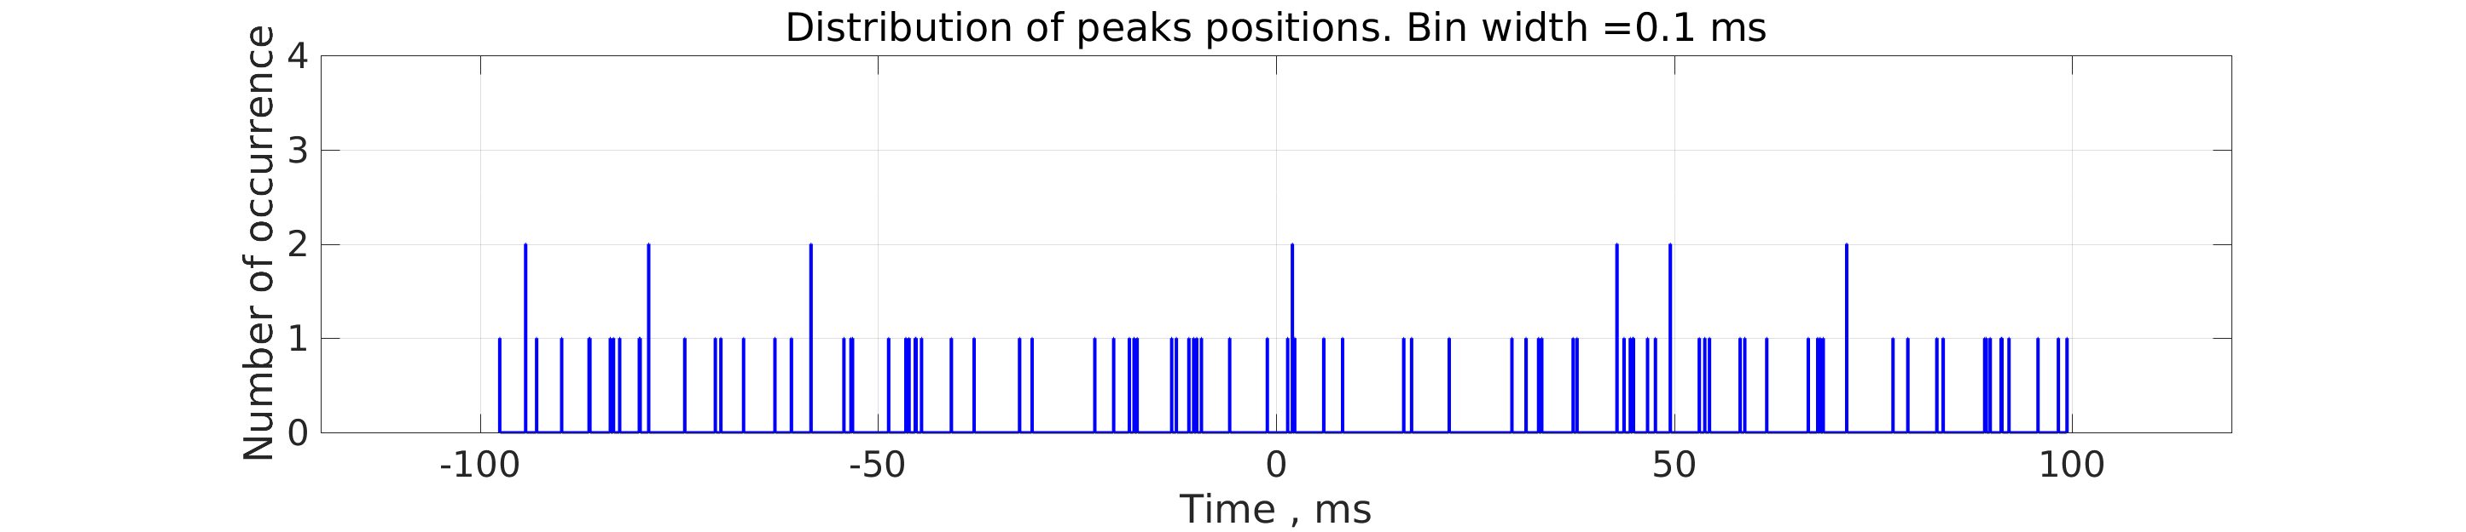

**Fig.8. Distribution of peaks’ positions. Bin width 0.1 ms. Upper panel: at the maximum of TGE , at 2:03:04UT October 6, 2021, Lower panel: background at fair weather at 20:59:18 UT October 6, 2021.**

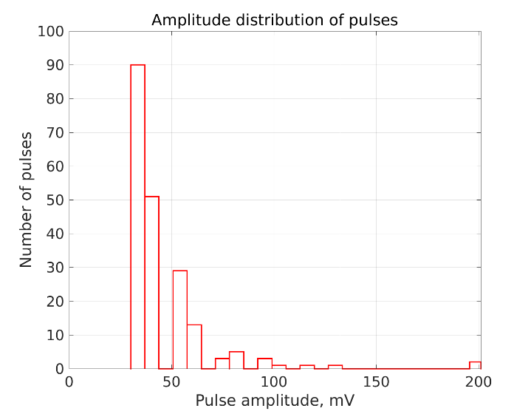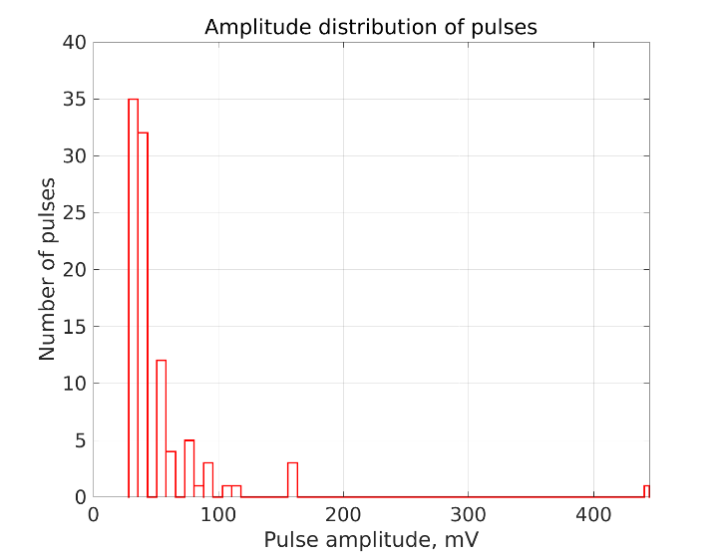

**Fig.9. Distribution of pulse amplitudes. Bin width 8 mV. Left: at the maximum of TGE, at 2:03:04UT October 6, 2021, right: background at fair weather at 20:59:18 UT October 6, 2021.**

1. **Picoscope N4 SKL2. Signal of Cube 6 detector (Ch C of Picoscope).**

Record length 200 ms, sample interval 6.4 ns. Amplitude measurement range ±2 V, amplitude resolution 16 mV. Filtering by amplitude is applied: pulses with amplitudes below given threshold (48 mV or 32 mV) are removed.

**2a) Threshold 48 mV**

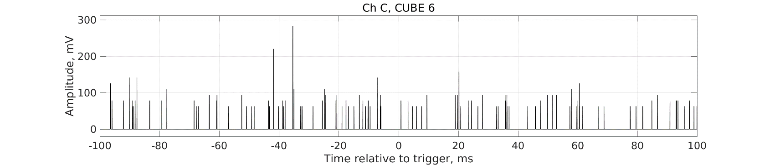

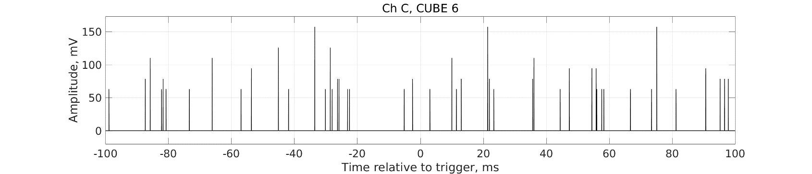

**Fig.10. Inverted signal of Cube 6 detector (Ch C of Picoscope). Upper panel: at the maximum of TGE , at 2:03:09UT October 6, 2021, number of peaks is 108. Lower panel: background at fair weather at 11:56:01 UT October 6, 2021, number of peaks is 47.**

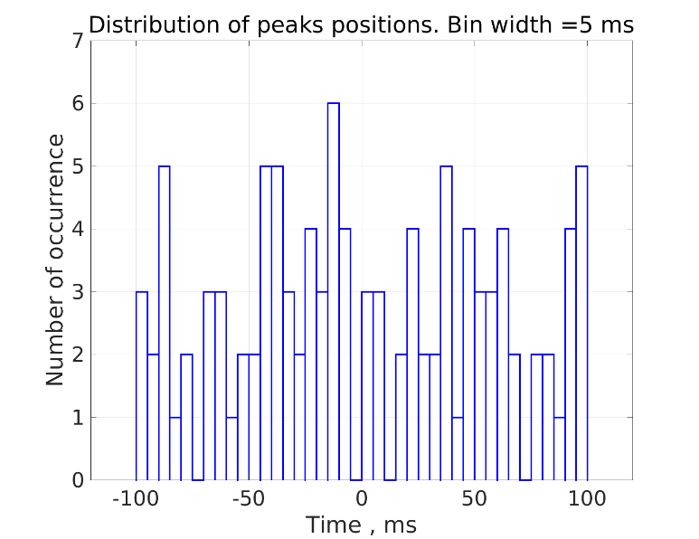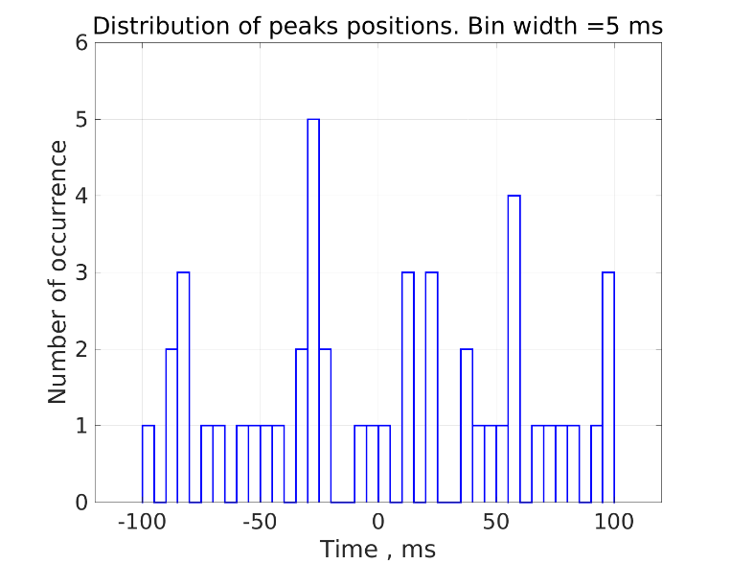

**Fig.11. Distribution of peaks’ positions. Bin width 5 ms. Left: at the maximum of TGE , at 2:03:09UT October 6, 2021, right: background at fair weather at 11:56:01 UT October 6, 2021.**

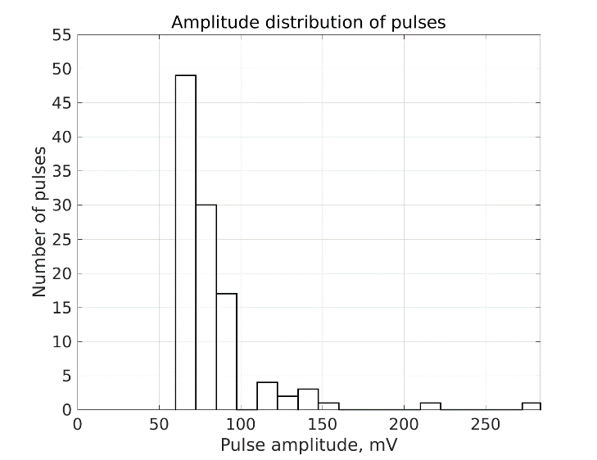 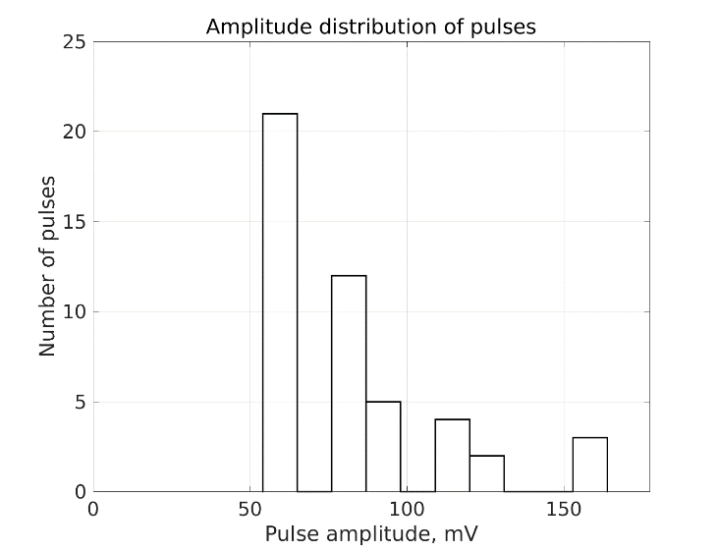

**Fig.12. Distribution of pulse amplitudes. Bin width 16 mV. Left: at the maximum of TGE, at 2:03:09UT October 6, 2021, right: background at fair weather at 11:56:01 UT October 6, 2021.**

**2b)Threshold 32 mV**

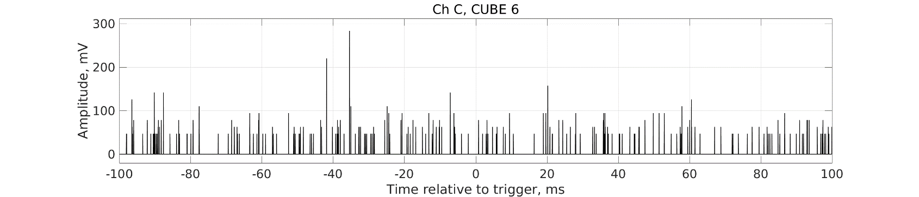

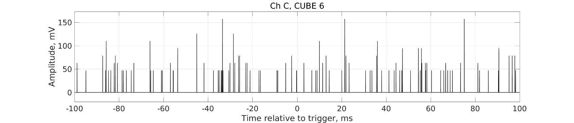

**Fig.13. Inverted signal of Cube 6 detector (Ch C of Picoscope). Upper panel: at the maximum of TGE , at 2:03:09UT October 6, 2021, number of peaks is 214. Lower panel: background at fair weather at 11:56:01 UT October 6, 2021, number of peaks is 103.**

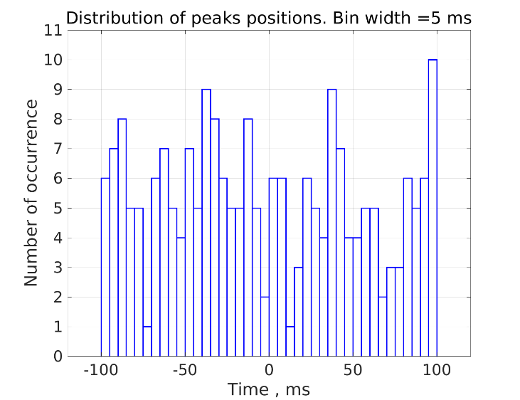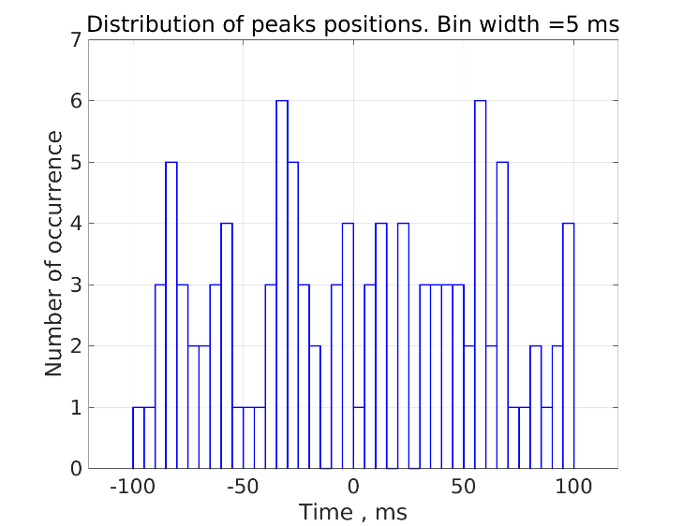

**Fig.14. Distribution of peaks’ positions. Bin width 5 ms. Left: at the maximum of TGE , at 2:03:09UT October 6, 2021, right: background at fair weather at 11:56:01 UT October 6, 2021.**

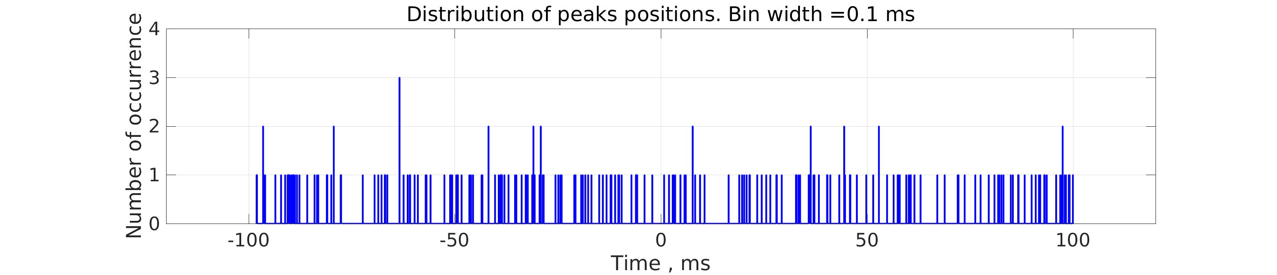

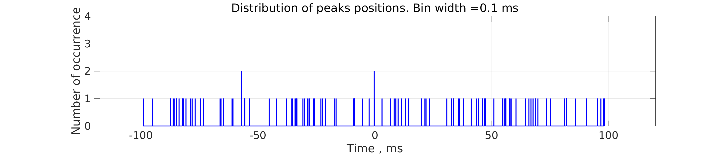

**Fig.15. Distribution of peaks’ positions. Bin width 0.1 ms. Upper panel: at the maximum of TGE , at 2:03:09UT October 6, 2021, Lower panel: background at fair weather at 11:56:01 UT October 6, 2021.**

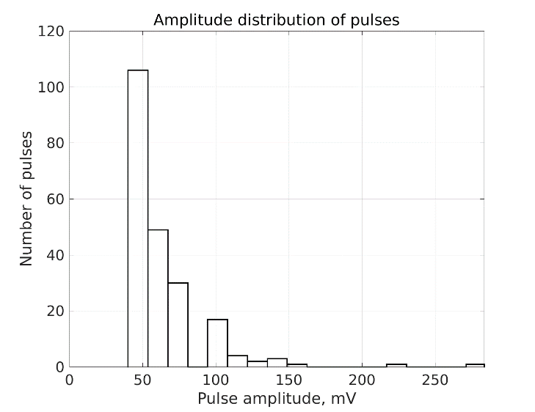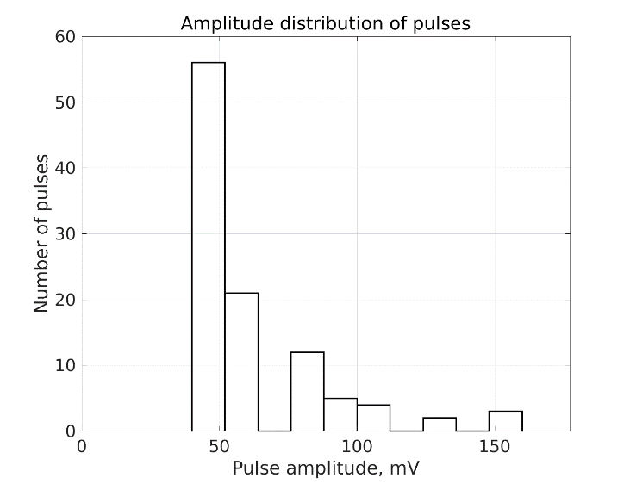

**Fig.16. Distribution of pulse amplitudes. Bin width 16 mV. Left: at the maximum of TGE, at 2:03:09UT October 6, 2021, right: background at fair weather at 11:56:01 UT October 6, 2021.**

**Table 2. Number of pulses in the 200-ms record of signal from 3 cm outside detector (MAKET) at the maximum of TGE , at 02:03:04 UT and in background record for two different thresholds used for filtering.**

|  |  |  |  |  |
| --- | --- | --- | --- | --- |
| **Detector** | **Filtering threshold (mV)** | **Number of pulses during TGE** | **Number of pulses of background** | **Ratio,**  **TGE/ background** |
| 3cm scint | 32 | 109 | 63 | 1.7 |
| 3cm scint | 24 | 199 | 98 | 2.0 |

**Table 3. Number of pulses in the 200-ms records of signals Cube 2, Cube 3, and Cube 6 detectors (SKL2) at the maximum of TGE , at 02:03:09 UT and in background record for two different thresholds used for filtering.**

|  |  |  |  |  |
| --- | --- | --- | --- | --- |
| **Detector (Ch)** | **Filtering threshold (mV)** | **Number of pulses during TGE** | **Number of pulses of background** | **Ratio,**  **TGE/ background** |
| CUBE 2 (Ch A) | 48 | 176 | 74 | 2.4 |
| CUBE 2 (Ch A) | 32 | 250 | 112 | 2.2 |
| CUBE 3 (Ch B) | 48 | 102 | 42 | 2.4 |
| CUBE 3 (Ch B) | 32 | 182 | 66 | 2.8 |
| CUBE 6 (Ch C) | 48 | 108 | 47 | 2.3 |
| CUBE 6 (Ch C) | 32 | 214 | 103 | 2.1 |

**Summary**

At the maximum of the TGE, significant increase of the number of pulses in the signals of scintillation detectors is observed in 200-ms oscilloscope records. For the analyzed records of four scintillation detectors with two different thresholds applied for removal of pulses with small amplitude , the increase of 1.7-2.8 times is observed compared to the background records. The pulses are randomly distributed over the whole record length, no detectable group of pulses (short burst) can be found in the distribution of positions of pulses on the time axis. Histograms of pulse positions with bin widths from 5 ms to 100 µs do not have any pronounced maximum. Amplitude distribution of pulses shows dominant contribution of pulses with small amplitude, both for the background records and for records during TGE.

**Appendix A. Record of neutron burst of 2016 processed with same software**

Burst detected by neutron monitor at 15:39:56 UT on November 29, 2016.

Record length 100 ms ( -20 ms, 80 ms), sample interval 4 ns, amplitude measurement range ±5 V, amplitude resolution 40 mV.

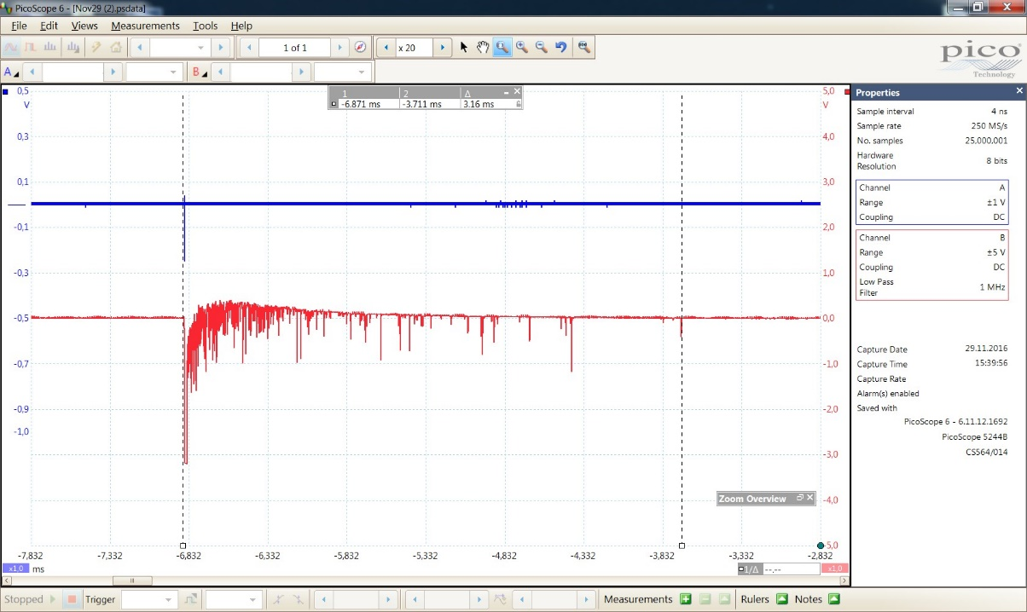

**Fig.A1. Oscilloscope record (red) of neutron burst detected by neutron monitor at 15:39:56 UT on November 29, 2016.**

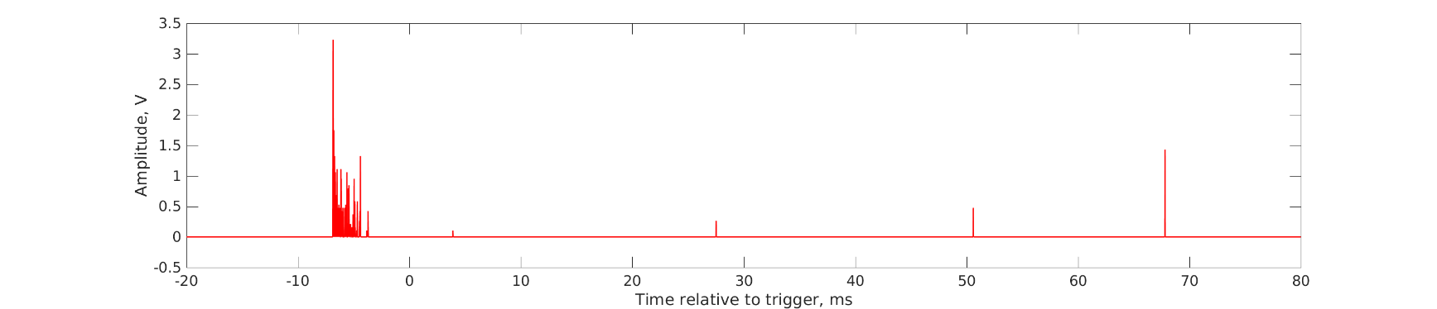

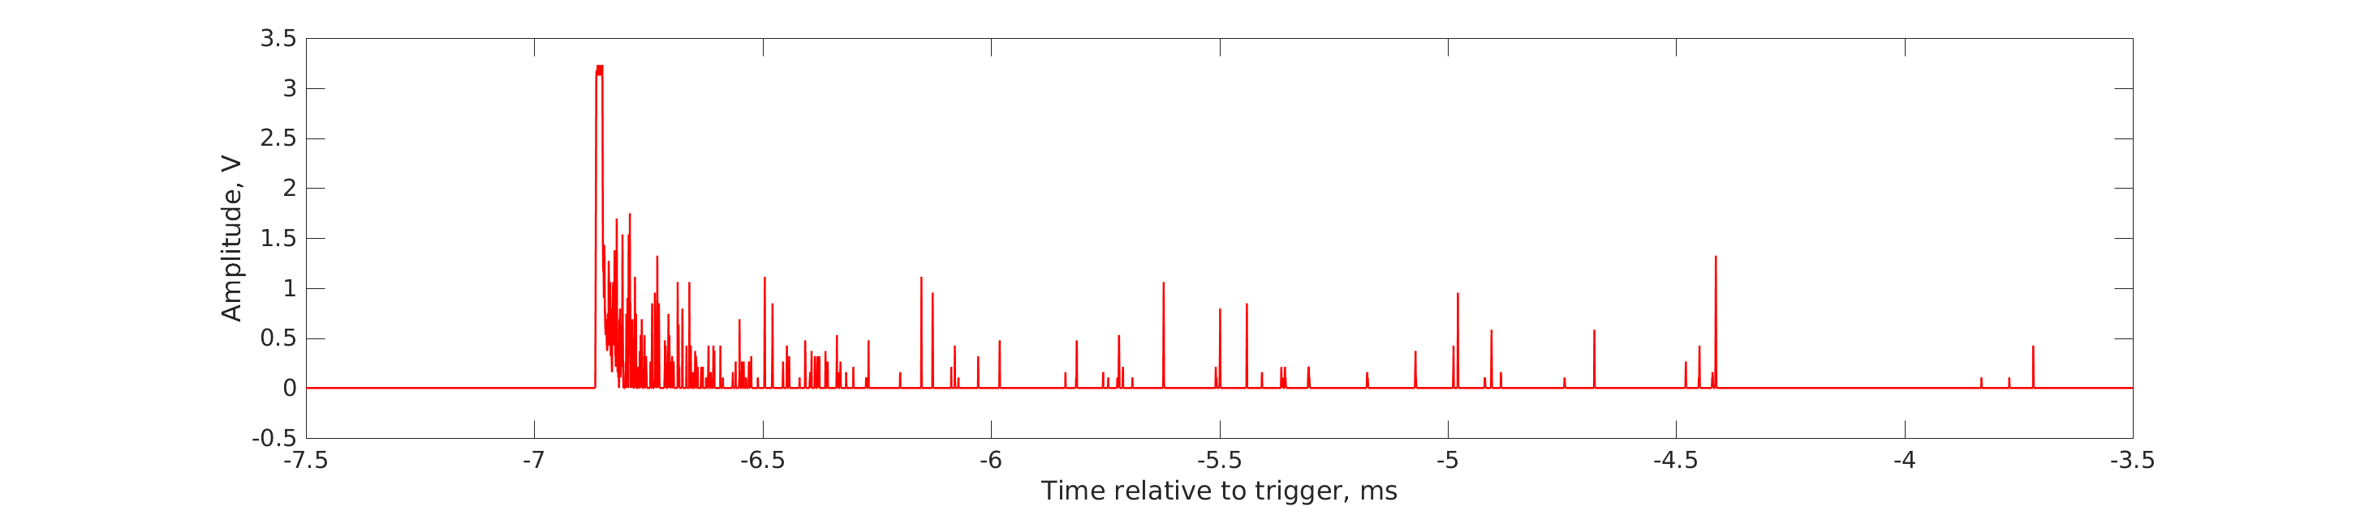

**Fig.A2. Inverted signal of neutron monitor filtered by amplitude : pulses with amplitudes below 80 mV are removed. Record length 100 ms. Number of peaks is 172.**

**Upper panel: full record, lower panel: time window (-7.5, -3.5) ms.**

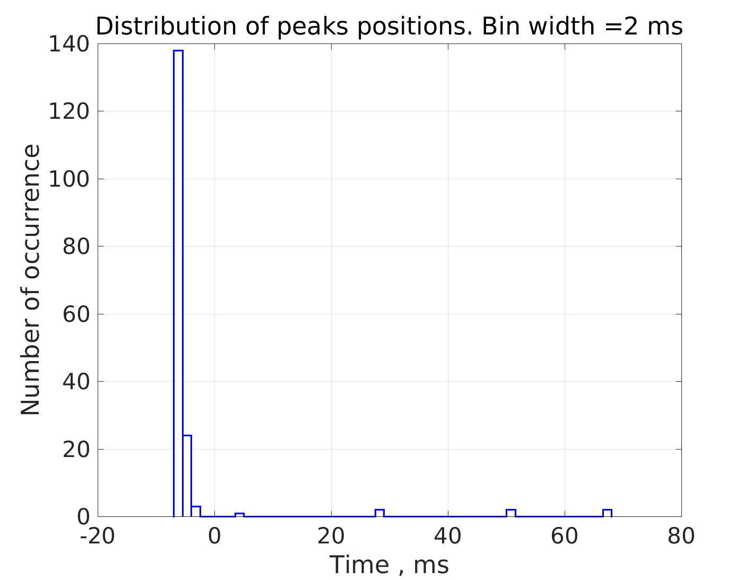

**Fig.A3. Distribution of peaks’ positions. Bin width 2 ms.**

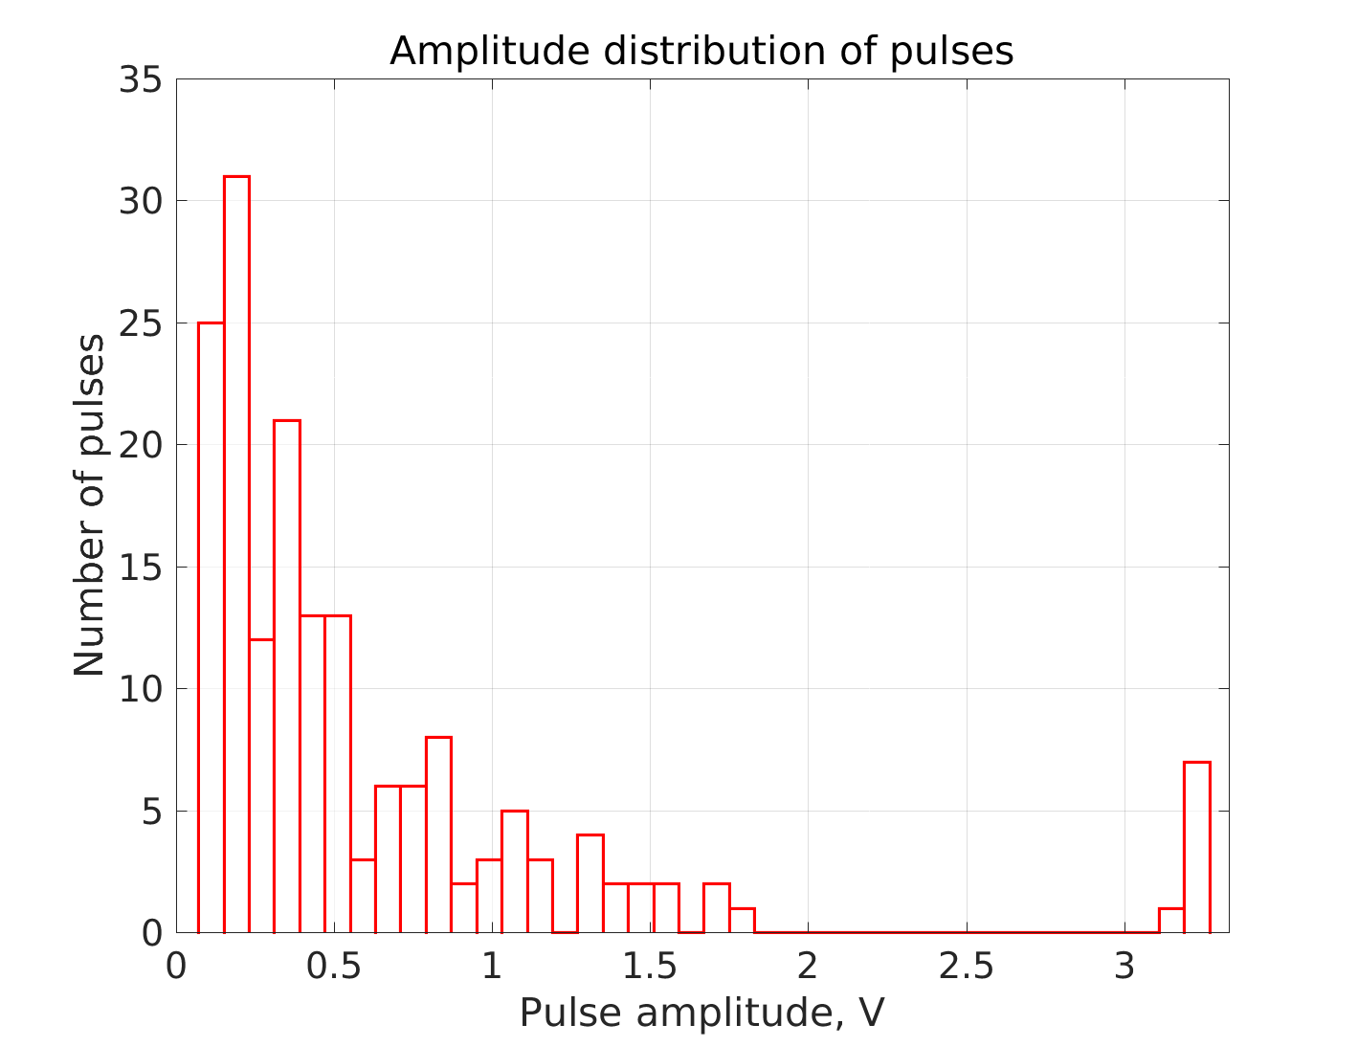

**Fig.A4. Distribution of pulse amplitudes. Bin width 80 mV.**