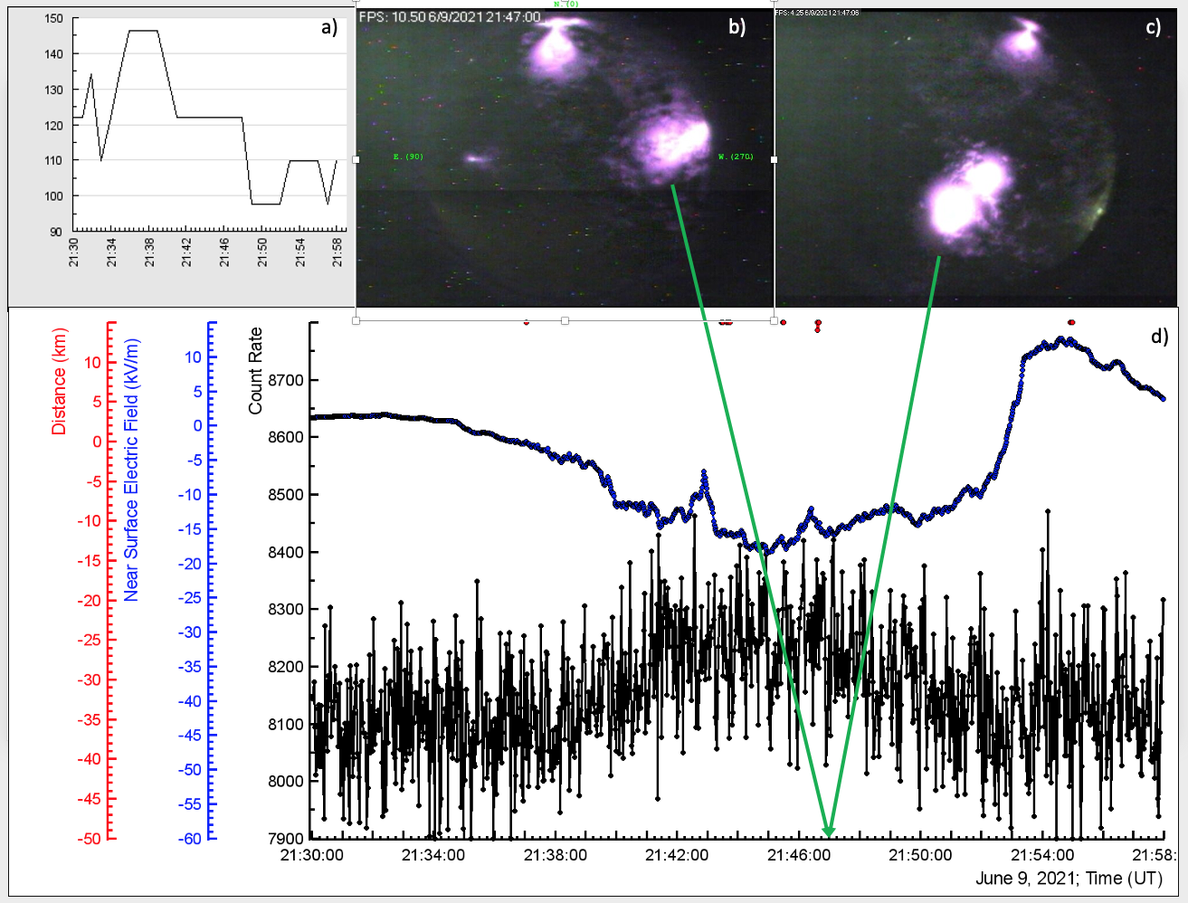

**Figure 8. d) time series of NS electric field measurements (blue, EFM-100, Boltek company); time series of count rate of 60 cm tick and 4 m2 area plastic scintillator (black ASNT detector, energy threshold 4 MeV); a) distance to lightning flash (estimated with the same “electric mill” EFM-100, red); c) and d) shots of 2 panoramic cameras located on the distance 100 m from each other. By green arrows we show the time when the shots were taken by both cameras.**

TGE occurred during prolonged (12 minutes) negative NS electric field of -17 kV/m, disturbed by 2 excursions in the direction of positive field, however, didn’t reaching positive domain (-12 kV/m at 21:42:51, and -6.6 kV/m at 21:46:26). The distance to cloud base was less than 100 m.

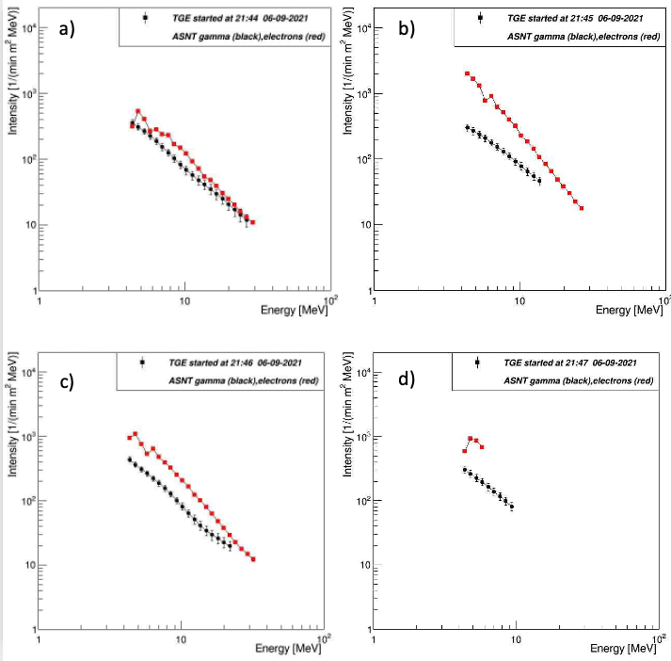

Figure 9.**Recovered differential energy spectra of the electrons (red) and gamma ray (black) of TGE, registered by ASNT detector (one-minute time series obtained by summing 3 20 sec time series).**

